# 地编

## 序列化

MapEditor.MapObjectRoot.ins.SerializeToJson()

EditorSerialize.ToJson(挂在MapEditor/Maps下面)

EditorSerializeObjectsRoot.SerializeObject

EditorSpawnPointsRoot.SerializeObject

EditorWeaponSpawnPointsRoot.SerializeObject

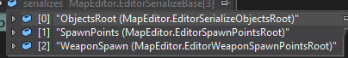

### 11

## 反序列化

//运行模式下 顶级控制脚本

RuntimeSerialize

## 截屏

MapRuntimeCapture🡪RuntimeSerialize

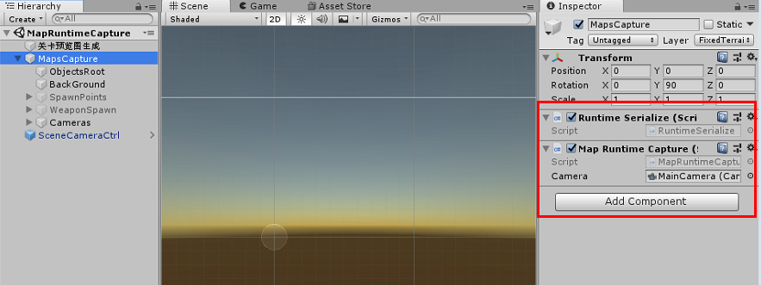

## 正式游戏加载地图

RuntimeSerialize.Load(long customs = 0)

## 层

## 发布地图

### 请求id

RpcClient.ins.SendRequest("map", "upload_map", "uuid:" + StaticData.uuid + ",", (RpcRespone msg1) =>

### 上传地图

RpcClient.ins.SendRequest<rpc.MapUpload>("map", uploadMethod, t, (RpcRespone ss) =>

### 下载地图

获取推荐地图:（获取ID列表）

SEND_RPC_JSON_JSON("map","request_map_info_top_hot","index:"..self.index_r..",",function(json)

根据地图ID获取详细信息:

SEND_RPC_JSON_JSON_NIL("map","map_info_detail_my_one","uuid:"..uuid..",",function(json)

Image控件设置ImageMap

--设置图片为 地图

function t:SetImageMap(uuid)

    if uuid and self.raw then

        CS.LuaCodeBridge.MapCaptureAsyncGetSprite(tostring(uuid),function(sp)

            if sp and self.raw then

                self.raw.sprite = sp;

            end

        end,284,160);

    end

end

### 下架地图

SEND_RPC_JSON_JSON("map","map_remove_from_pool","uuid:"..DataMgr.DataAccountInfo:GetUUID()..",id:"..uuid_map..",",function(json)

## 地图存储位置

QA DEV 测试服对应一个CDN

正式服对应一个CDN

QA DEV 测试服 地图 Id共用，但玩家看不到QA服上传的地图

## 地图测试开房间

map_pool_1.lua 改成自己的地图id

# 地编-层

## 分层修改的地方:

### MapEditor/Maps/BackGround

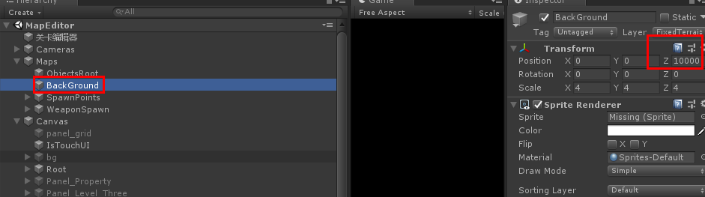

### MapRuntimeCapture/MapsCapture/BackGround

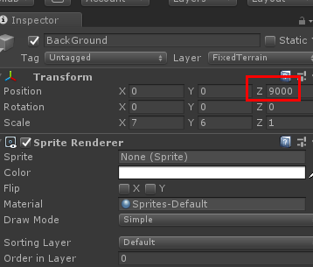

### MapEditor/Cameras/MainCamera

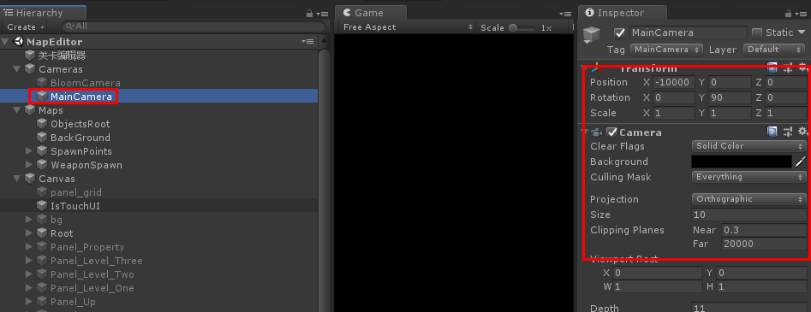

### MapRuntimeCapture/Cameras/MainCamera

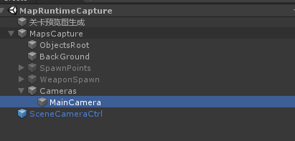

### MapEditorPreview/Cameras/MainCamera and BloomCamera

MainCamera,

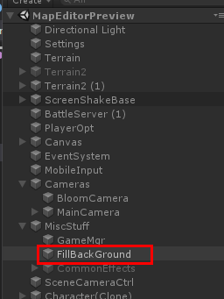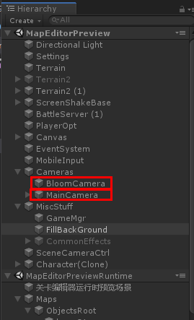

### BackGround.cs

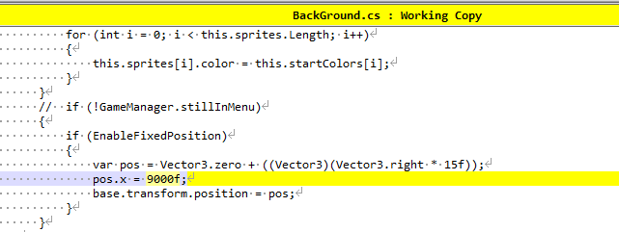

### GameLobby/Cameras/BloomCamera and MainCamera

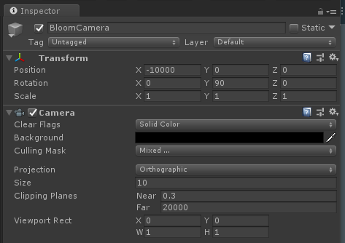

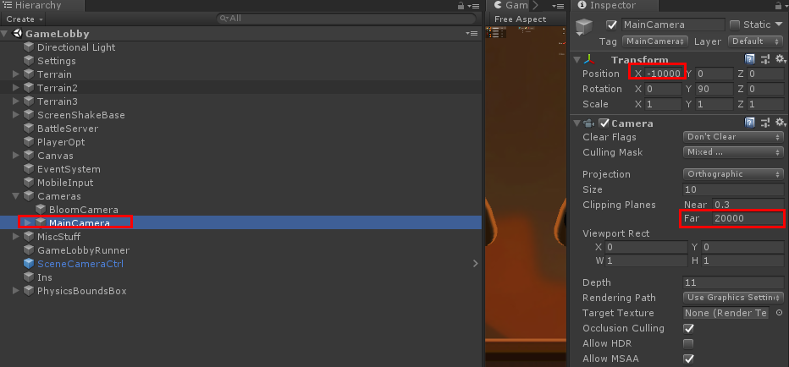

### GameMgr.cs 3054

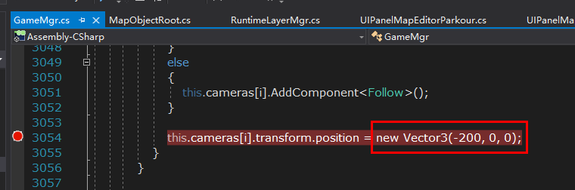

### UIPanelMapEditorParkour.cs 281

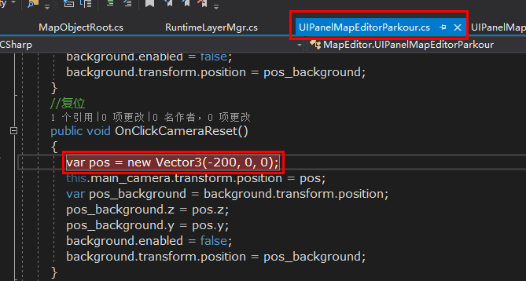

### UIPanelMapInfoParkour.cs 281

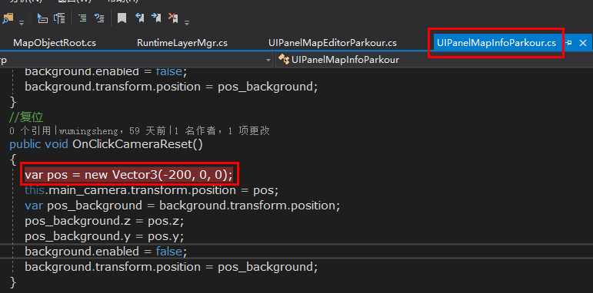

## Z有坐标的情况下世界坐标x改不了？

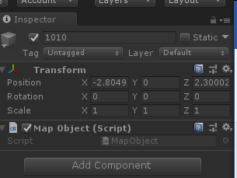

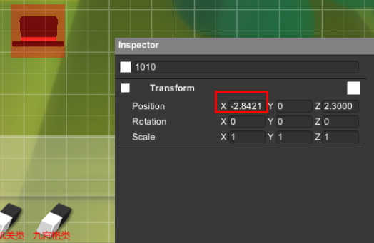

# Server

## redis

runcluster.bat

### 设置地图起始ID (注意是MAX_MAP_ID_GEN(地图) 不是MAX_UUID_GEN(火柴号))

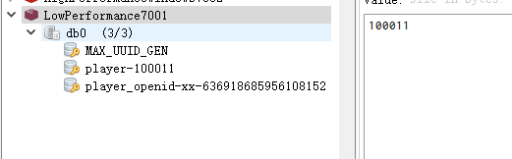

11500000

12000000 QA

# 证书

